

**E VOTING WEBSITE**

### 

### **A PROJECT REPORT**

***Submitted by***

**Archi Agarwal (2115000194),**

**Ashmit Garg (2215990015),**

**Hemant Kumar (2215990030),**

**Rhythm Chaurasia (2215990049)**

***in partial fulfillment for the award of the degree of***

**BACHELOR In TECHNOLOGY**

**IN**

#### Computer Science Engineering and Application

**GLA University, Mathura**

**NOVEMBER 2023**

#### **BONAFIDE CERTIFICATE**

Certified that this project report **“E-VOTING WEBSITE”** which carried out the project work under my/our supervision.

|  |  |
| --- | --- |
|  |  |
| <<Signature of the HoD>>  **SIGNATURE**  Dr.Rohit Agarwal  **HEAD OF THE DEPARTMENT**  CEA Department | <<Signature of the Supervisor>>  **SIGNATURE**  Prof. Sanjay Madaan  **SUPERVISOR**  Technical Trainer  CEA Department |

Submitted for the project viva-voce examination held on 29/11/2023

**INTERNAL EXAMINER EXTERNAL EXAMINER**

**ACKNOWLEDGEMENT**

We would like to extend our sincere appreciation and gratitude to all the individuals and organizations who have contributed to the successful completion of this mini project.

First and foremost, we would like to express our heartfelt thanks to our esteemed mentor “Prof. Sanjay Madaan” for his unwavering support, valuable guidance, and insightful feedback throughout the duration of this project. His expertise and encouragement have been pivotal in shaping the direction of our work and have inspired us to deliver our best.

We would also like to acknowledge the collaborative efforts and contributions of each member of our group. Working together as a team has not only enriched our project with diverse perspectives but has also fostered a spirit of camaraderie and mutual support. Each member’s unique skills and dedication have played a crucial role in achieving our shared goals.

Furthermore, we are grateful to our friends and family for their understanding, encouragement throughout this endeavour. Their constant support has been a source of motivation during challenging times.

Lastly, we would like to thank the university administration for providing us with access to essential resources and facilities, which have been instrumental in the successful execution of our project.

**ABSTRACT**

The word “vote” means to choose from a list, to elect or to determine. The main goal of voting (in a scenario involving the citizens of a given country) is to come up with leaders of the people’s choice. Most countries, India not an exception have problems when it comes to voting. Some of the problems involved include ridging votes during election, insecure or inaccessible polling stations, inadequate polling materials and inexperienced personnel. This online voting/polling system seeks to address the above issues. It should be noted that with this system in place, the users, citizens in this case shall be given ample time during the voting period. They shall also be trained on how to vote online before the election time.

**Chapter-1 Introduction**

“ONLINE VOTING SYSTEM” is an online voting technique. In this system people who have citizenship of Bharat and whose age is 18 yearsand above and any sex can give his/her vote online without going to any physical polling station. There is a database which is maintained in which all the names of voters with complete information are stored. In “ONLINE VOTING SYSTEM” a voter can use his/her voting right online without any difficulty. He/she can vote and select type of election ant to vote and choose its respective party nad choosing got a notice indow of being registered. Also user can see those parties which are ging to participate in election.

**1.1 SIGNIFICANCE OF STUDY**

The main purposes of OVS include:

1. Provision of improved voting services to the voters through fast, timely and convenient voting.
2. Reduction of the costs incurred by the Election Commission of Bharat during voting time in paying the very many clerks employed for the sake of the success of the manual system.
3. Online voting system (OVS) will require being very precise or cost cutting to produce an elective election management system.
4. Therefore, crucial points that this (OVS) emphasizes on are listed below.
5. Require a smaller number of staff during the election
6. This system is a lot easier to independently moderate the elections and subsequently reinforce its transparency and fairness.
7. Less capital, less effort, and less labor intensive, as the primary cost and effort will focus primarily on creating, managing, and running over secure online.
8. Increased number of voters as individual will and it easier and more convenient to vote, especially those abroad.

**1.2 Objectives of the PROJECT**

The specific objectives of the project include:

* Reviewing the existing/current voting process or approach in India
* Coming up with an automated voting system in India
* Implementing an automated/online voting system

**1.3 Project justification**

The ONLINE VOTING SYSTEM-INDIA shall reduce the time spend making long queues at the polling stations during voting. It shall also enable the voters to vote from any part of the globe as explained since this is an online application available on the internet. Cases of vote miscount shall also be solved. Since the voting process shall be open as early as possible, the voters shall have ample time to decide when and whom to vote for.

**1.4 SCOPE OF STUDY**

It is focused on studying the existing system of voting in India and to make sure that the peoples vote is counts, for fairness in the elective positions. This is also will produce:

* Less effort and less labor intensive, as the primary cost and focus primary on creating, managing, and running a secure web voting portal.
* Increasing number of voters as individuals will and it easier and more convenient to vote.
  1. **Identification Of Problem**

1. People can vote from anywhere.
2. Cost of deployment is cheap.
3. Looks appealing.
4. People who doesn’t to vote on polling they can also vote at their home.
5. Parties can do thei promotion.

**Chapter-2 Literature Survey**

**2.1. Reviews Of Different E-voting Systems:**

E-voting system is a proactive area of research and updated year by year by new methodologies, functionalities and new approaches. The engineers and researchers who have done their work in an area of Electronic Voting posting that these voting systems does not fulfill the requirements of public elections, there are still some security problems in it and second the current advanced technologies of these system is still need to be improved. So here are some reviews about researches done by individuals and groups on E-voting systems and also the international status on electronic voting is described below:

This project proposed the multifaceted E-voting system, where voters can cast their votes using a Computer networks, web browsers and mobile phones. The system was based on the three tier architecture: client, server and database. The system interacts between this architecture through application servers which are: GSM modem (GPRS or SMS server), Internet server (Web) and VPN networks (Poll server). These application servers are connected with the database server. The registered voters have a unique number and a voting code. Internet voter (client) cast his vote through URL (web browser) by his unique number and a voting code while SMS voting requires a code and integration of mobile number. Poll site voting also requires a code and fingerprint template for casting the vote. All the votes are stored in database server and counted at a time.

This thesis proposed a decentralized electronic voting system application for android devices such as Smart phones and tablets. The term “decentralized” means there is no central server involved in election process. This E-voting system is used when low number of participants involved. CGS97 voting protocol is implemented automatically on each device on the installation of an application. The administrator creates an ad-hoc network with mobile device with the help of an application and the other participants joined this network by scanning the QR code from the administrator device to participate in voting. The administrator creates questions with some specific options which are automatically displayed on participant’s devices due to the ad-hoc network. The participants select their answers and these answers are saved on the administrator device. In order to verifiability and privacy, a voting protocol uses a homomorphic tallying scheme

**2.2. International Status on E-voting System:**

This section provides an overview on E-voting experience in various countries. It also proposed the various E-voting systems which are implemented at international level. There are some countries where the E-voting system is implemented are:

**2.3. Summary:**

So according to overall background study, analysis, experience, and comparison it is stated that Technology implementation and up-gradation in elections are always challenging and require careful consideration and planning. This study proposed that E-voting provides an opportunity for solving some traditional problems but also introduces new concerns. This study also discusses some typical features and technological solutions of E-voting and provides an overview of the weaknesses and strengths of this technology. At last, this technology still needs to be improved to enhance the efficiency and usability of the elections

**Chapter 3: Methodology**

**3.1. Overview:**

This chapter describes the detail work on the project that what methodologies are used to achieve the progress of *web-based voting system*. This section describes the framework, functionalities, challenges, requirements, and specifications that are required to implement on this system. This chapter also demonstrates the overall tools, design, planning, implementation and the whole process and its work flow. Generally, this chapter describes the core development of the whole *E-voting website*.

The above chapter presented the variety of methods and technologies that are used to design the different E-voting systems. These systems can be used in universities, organizations and also in countries. Many researches have been done to upgrade the efficiency and eliminate the errors of these systems that may occur during the election process. The developers and researchers have faced some challenges, shortages, limitations and troubles during these projects which accommodate us in creating such a system that widely covers to overcome on these problems.

**3.2. Research Approach:**

The research goes through different steps to complete the project (*online voting system*). The research will be divided into four steps which are shown in the figure below:

FIGURE: 3.1. Steps of Research Approach

**3.3. Problem Identification**:

Different E-voting systems have introduced to enhance the election process. These systems are regularly analyzed and examined for correctness and security. A variety of researches have specified that all or most of the E-voting system getting used are faulted and not done their task properly. From this point of view our most significant task is to develop an easy and efficient prototype of E-voting system based on android application with enhanced security and protection of the system. This can be attained by upgrade the different measures such as security actions and verification methods and by avoiding mistakes done by others in their systems or machines.

**3.4. Technical Research:**

The technical research is a core process related to E-voting system components such as the programming language, user interface, algorithm for AADHAR verification etc. AADHAR is used despite of fingerprint or other biometric as it already has biometric verification so it serves as double security systems

**3.5. Project Process Chart:**

The flow chart has been used to simplify the understanding. The flowchart basically a diagram consists of symbols to show the flow of the whole project process. All the steps should be executed to attain the result of the project. The below chart shows the project process

System Testing

Start

System Design

Software Research

Hardware Research

Software Development

Techn.

Troubleshooting

Improvised by Testing

End

NO

YES

**3.6. System Components**:

There are many types of components are used in making a prototype model of different electronic voting systems. This prototype is the result of the software and hardware integration. The prototype also shows the architecture, elements, and components of the system. To design and develop an *online voting system*, extensive research must be completed to develop the suitable software/website that is capable to meet the system requirements and be well organized and integrated. There are some technical requirements which must be considered during developing a website.

**3.7. System Design:**

The system designing process starts when the research has been completed about the languages that will be used in the development of a website to achieve the task. Following languages are used:

* HTML
* CSS
* JavaScript

Research and Study

Planning

Programming

check

Troubleshooting

NO

YES

Finalize and Complete

FIGURE: 3.7. System Design Flowchart

System designing is divided into two parts which are system architecture and system development. Architecture part shows the conceptual overview of the main parts of the system while the development part shows the functional overview of the system.

**3.8. System Functionality**:

System functionality diagrams demonstrate how the data operate by an application that flows through the different processes. The voting system contains a fingerprint scanner, and Tablet as a user interface. There are two modes of authentication one is for the administrator that handles the registration panel and activate the voting process by login through his ID and password and for uniqueness ID means putting AADHAR number. Then a person go for seeking number and which party is going to nominate for a particular election and choose the respected party by giving your valuable vote. At the end of the voting process the election result can be checked through result panel.

**User Interface**

**Vote**

**Feature Extractor**

**Feature Matcher**

**Database**

Yes

No

**Warning**

**Feature Extractor**

FIGURE: 3.16. System Functionality Block Diagram

**Chapter 4: Technologies To Be Used**

**4.1 HTML-5**

It provides basic and advanced concepts of HTML. Our HTML tutorial is developed for beginners and professionals. In our tutorial, every topic is given step-by-step so that you can learn it in a very easy way. If you are new in learning HTML, then you can learn HTML from basic to a professional level and after learning HTML **with** CSS and JavaScript you will be able to create your own interactive and dynamic website. But Now We will focus on HTML only in this tutorial.

The major points of HTML are given below:

1. HTML stands for HyperText Markup Language.
2. HTML is used to create web pages and web applications.

**4.2 CSS**

CSS tutorial or CSS 3 tutorial provides basic and advanced concepts of CSS technology. Our CSS tutorial is developed for beginners and professionals.

The major points of CSS are given below:

1. CSS stands for Cascading Style Sheet.
2. CSS is used to design HTML tags.
3. CSS is a widely used language on the web.
4. HTML, CSS and JavaScript are used for web designing. It helps the web designers to apply style on HTML tags.

**4.3 JavaScript**

**JavaScript (JS)** is a lightweight interpreted (or just in time compiled) programming language with first class functions. While it is most well-known as the scripting language for Web pages, many non-browser environments also use it, such as Node.js, Apache CouchDB and Adobe Acrobat. JavaScript is a prototype-based, multi-paradigm, single-threaded, dynamic language, supporting object-oriented, imperative, and declarative (e.g., functional programming) styles.

JavaScript's dynamic capabilities include runtime object construction, variable parameter lists, function variables, dynamic script creation, object introspect, and source-code recovery (JavaScript functions store their source text and can be retrieved.

This section is dedicated to the JavaScript language itself, and not the parts that are specific to Web pages or other host environments. For information about API that are specific to Web pages, please see Web API and DOM.

**Chapter 6: REQUIREMENTS**

**System Requirements:**

1. **Requirements at developer's end:**

**Hardware: Operating System:** MS Windows or UNIX or LINUX

**Language:** HTML, CSS, JavaScript, ReactJS

**RAM:** 512 GB or more

**Hard disk Required:** Greater than 5 GB

**Software:** Visual Studio Code

1. **Requirements at Client’s end:**

Hardware

Software

**Result and Some Snapshots of Code**

Login page

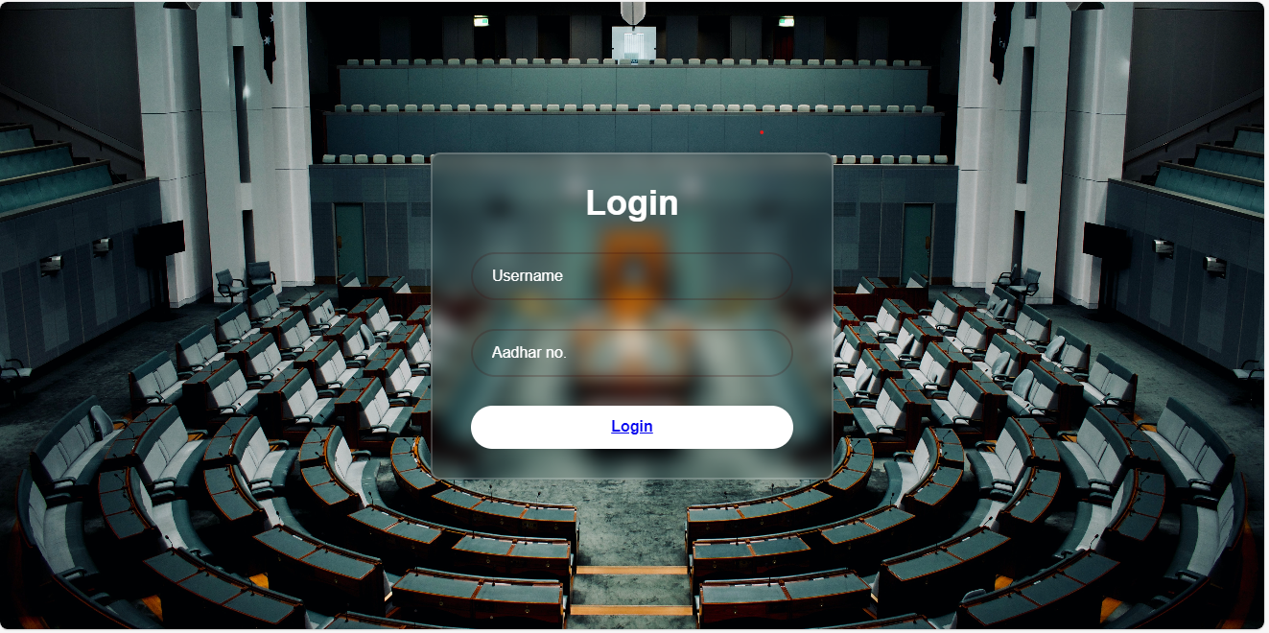Parties



Types Of Election

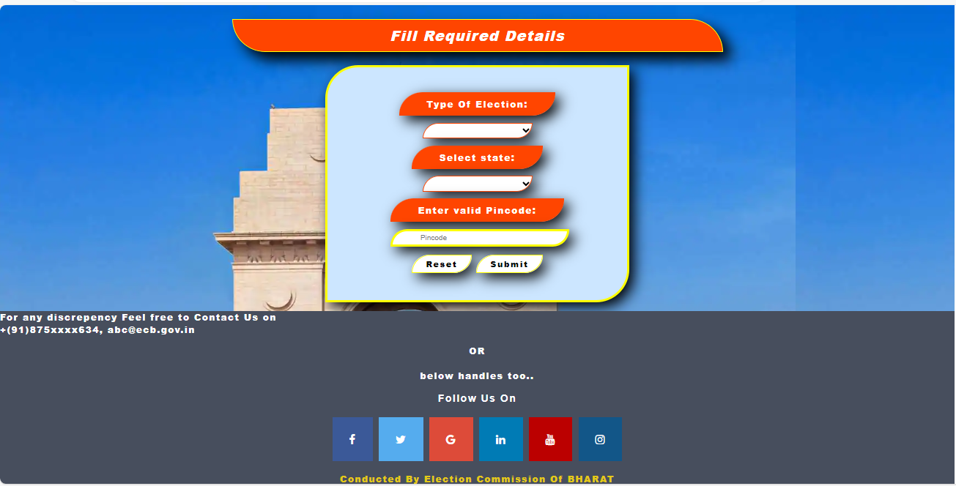

Select Party

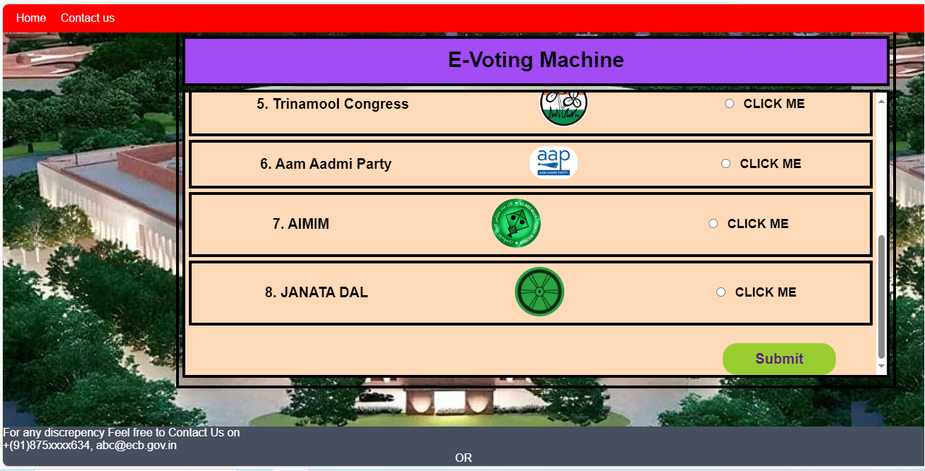

Thank you Page

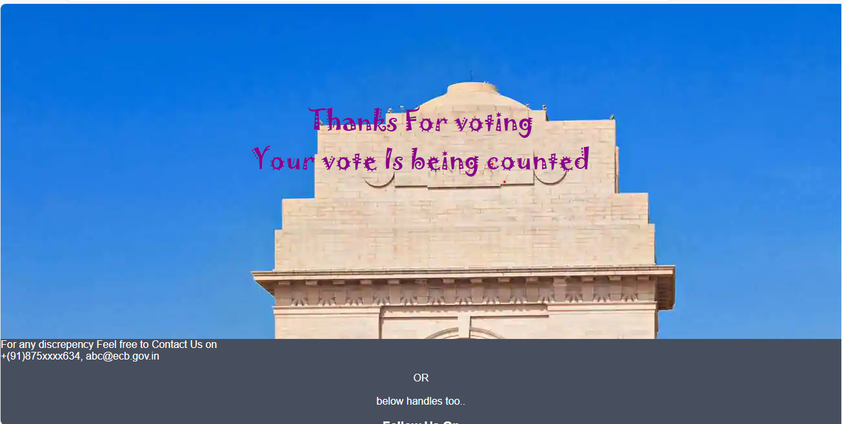

CODES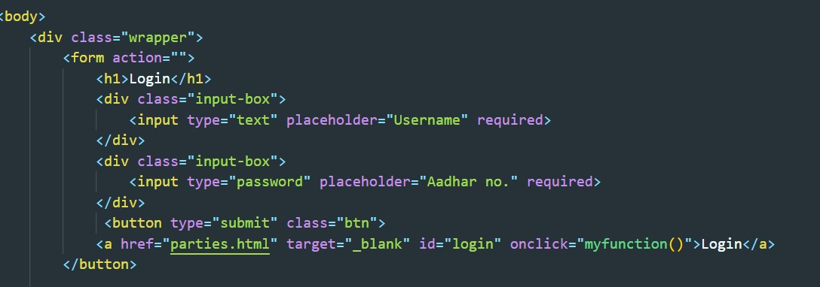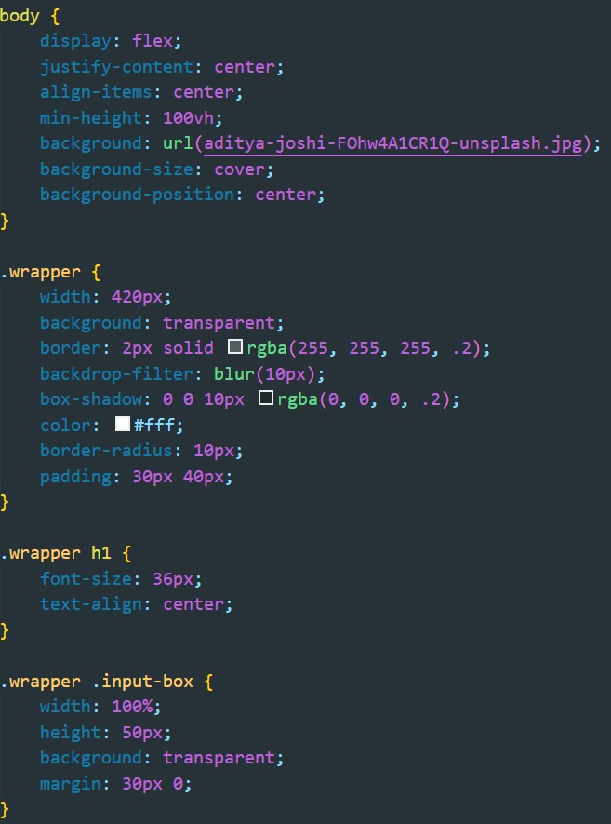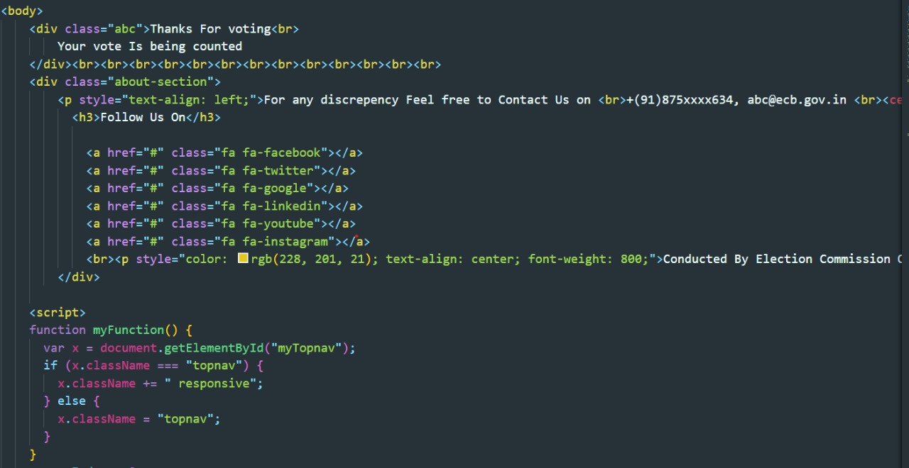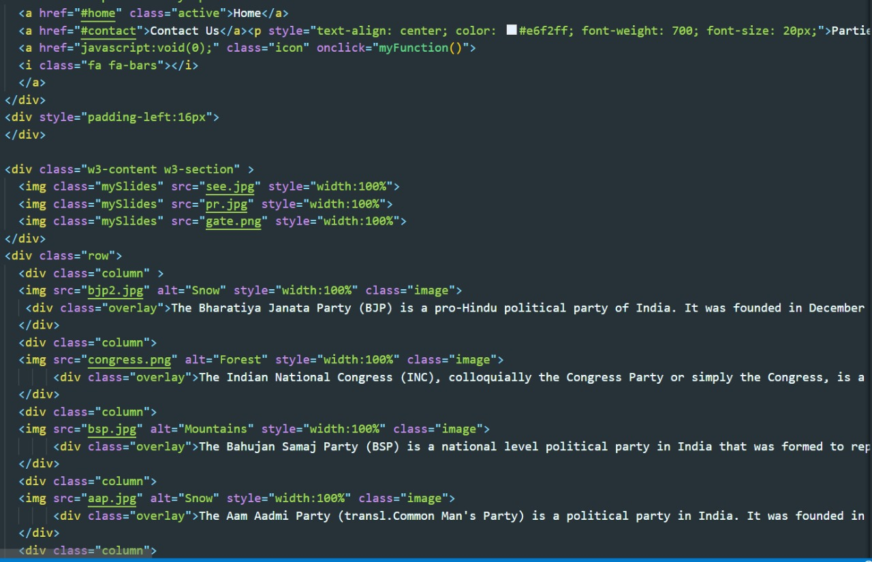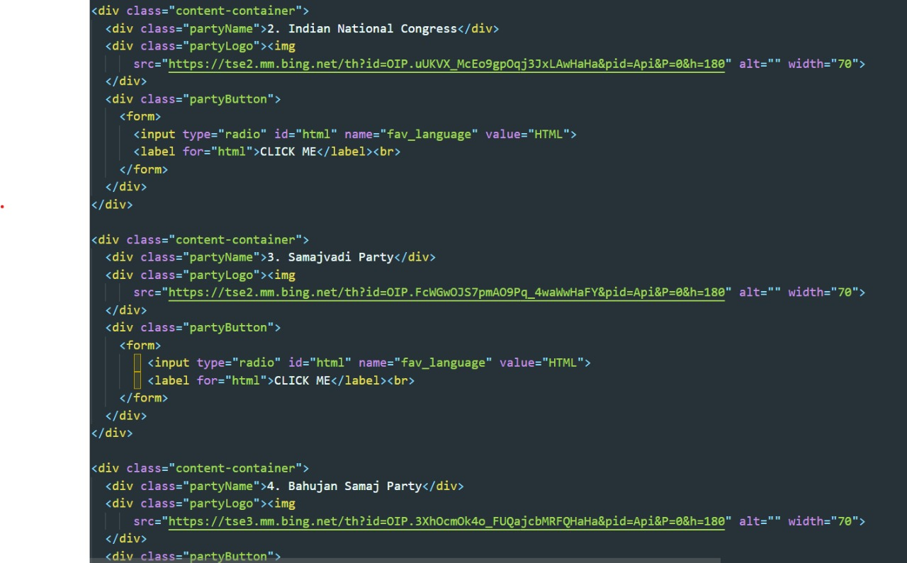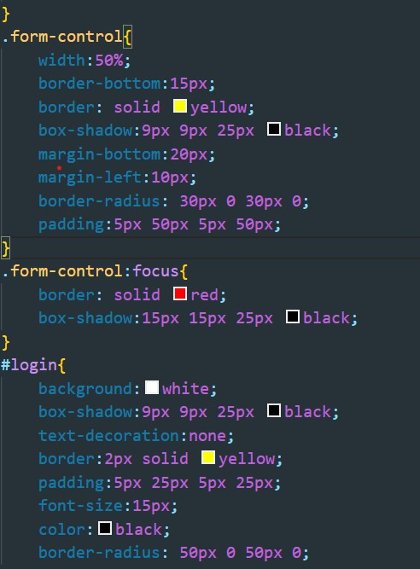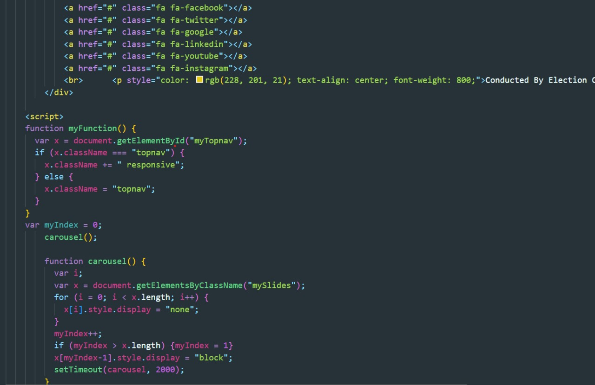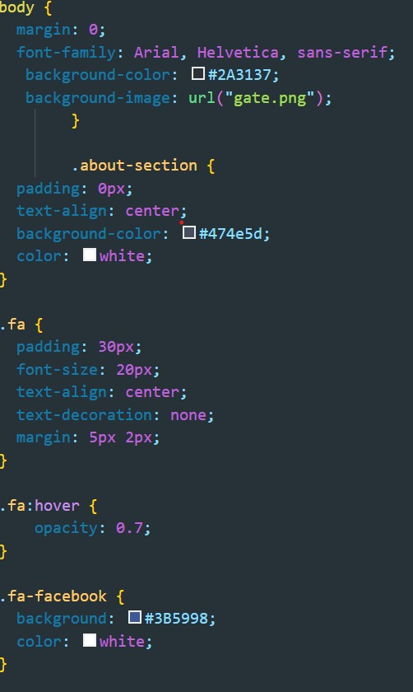

**Chapter 6: Conclusion and References**

**Conclusion**

This Online Voting system will manage the Voter’s information by which voter can login and use his voting rights. The system will incorporate all features of Voting system. It provides the tools for maintaining voter’s vote to every party. In this project voter after login by his/her username and Aadhar number he/she can see the number of parties nominating in election and can select types of election and from which state he/she belongs. After that he/she select the party to whom he/she wants to give his/her vote and submit it by clicking on submit button and receive a Thank You message. It decreases the cost and time of voting process. It is very easy to use and It is vary less time consuming. It is very easy to debug.

**References**

* **Mentor: Mr. Sanjay Madhan**
* [**http://w3schools.com**](http://w3schools.com)
* [**http://wikipedia.com**](http://wikipedia.com)
* **Standard books**
* **Youtube**
* **Github**

**GitHub link**:

gh repo clone chaurasiarhythm/midterm-project